**Spinning Tetrodes**

1. Cut 4 strands of 10cm long 10um wire
2. While holding one end of all 4 wires, dip fingers in water and run them along the length of the strands. The strands should stick to each other
3. Clamp both ends 2cm from the ends of the wires, leaving ~6 cm in the middle to be twisted
   1. Make sure the strands are sticking together / are the same length. Different lengths will lead to the wires snapping on the stir plate
4. Hang the clamps by the heavier clamp so that the lighter clamp is free to spin.
5. Spin at ~12.5 revs/s (3rd major tick mark on spin plate) for 40 seconds, until a density of ~67 turns/cm
6. Remove the spin plate and allow the tetrodes to freely unwind. When the clamps have stopped spinning, cut the wires at the middle of the 6 cm
7. Store the 2 new tetrodes in the Petri dish

**Soldering Tetrodes to Connector**

Looking from above:

**Front of connector (with lettering)**

|  |  |  |  |  |  |  |  |  |  |  |  |
| --- | --- | --- | --- | --- | --- | --- | --- | --- | --- | --- | --- |
| Empty | Empty | Tet A | Tet A | Tet A | Tet A | Tet B | Tet B | Tet B | Tet B | Empty | Empty |
| Empty | GROUND | Tet C | Tet C | Tet C | Tet C | Tet D | Tet D | Tet D | Tet D | REF | Empty |

**Back of connector**

1. Cut down the 4 free ends of a tetrode to around 1-1.5 cm.
2. Hold the 4 free ends of the tetrodes by the base. With the lighter, remove the insulation at the tips.
   1. Be careful to not remove the insulation where the wires start winding; this will create a short circuit
3. Solder the free ends to a Omnetics connector according to the diagram above
   1. Check that you are soldering the correct side – the connector has 8 front and 10 back pins
   2. If the wires are not soldering on easily (“dodging” the solder)
      1. Either the solder is too oxidized, add flux with the flux pen
      2. Or the wire is not stripped enough, remove the tetrode and strip the wire again
   3. If you are touching the other pins on accident, pull the pin upwards to separate it from the other pins, then push it back down after
4. Check the connectivity of the wires using the multimeter and a needle sticking into the connector holes.
   1. Touch one terminal to the needle and the other along the unsoldered wire. There should be a solid connection independent of the angle of the wire
5. Solder the ground and reference wires
   1. The ground wire is made from ~5cm of silver wire, flame-stripped along 2/3 of its length and at the tip. Solder to connector at the tip
   2. The reference wire is made from ~5cm of silver wire, flame-stripped only at the tip. Solder to connector at the tip.

**Add Connector to Microdrive Body**

1. Pinch the wires together and thread them through the top of the Microdrive. The connector sits at the top of the drive
2. Looking through the bottom of the Microdrive through the microscope, organize the wires
   1. I separate the front and back tetrodes from each other, putting the front tetrodes in front of the front bar where the screws go
   2. Clearly distinguish left and right tetrodes from each other
3. Mix 5-minute cure time epoxy. After around 2.5 minutes, hold the Microdrive upside down (careful to not let the connector fall out the Microdrive) and drip epoxy into the cavity where the wires come out of.
   1. Make the connector as straight and flat as possible
   2. Avoid getting epoxy into the connector holes. If it does, there’s not much you can do. It may block the drive from connecting to the amplifier
      1. You could try taping the connector holes before adding epoxy, though I have never tried this
   3. Avoid touching the wires as much as possible, since this will stick epoxy on them
      1. If epoxy gets on the wires, use a toothpick to wipe it off
4. Let the epoxy cure for ~15 minutes or overnight

**Make Microdrive Arms**

1. Get 2 microdrive arms. Check that they are mirror copies
2. Thread the screw holes of the arms with the tap. Make the threads as straight as possible
3. Thread a nut onto the tip of a screw. Add superglue to the outside of the nut with a toothpick.
4. Insert the nut into the hexagonal hole of arm. While the glue is setting, make sure the arm and the screw are as parallel as possible from all angles.
5. Remove the screw and let the arm dry. Repeat for the other arm
6. Check that the metal guide tubes can fit into the divot of the arms. If not, use the tube in the Petri dish to carve the divot wider.
7. Check that a screw can thread through the arm. If there is excess resistance, re-tap the hole.

**Prepare Guide Tubes**

1. With the Dremel thin cut blade, cut off ~1 cm tube pieces
   1. Wear a face shield because of metal particulates + I don’t trust the blade to not explode
   2. The tube gets pretty hot, use metal clamps to hold it while you cut
2. With calipers, measure and grind down pieces to 8mm in length.

**Option 1: Add Guide to Tetrodes, then Arms**

1. Widen guide tube holes with a needle
2. Thread a piece of silver wire through to get gunk out
3. Thread tetrodes through. The end of the tetrode can be folded to prevent the tube from falling off
4. Add the guide tubes to the arm
   1. Start with the CA3 deeper tube. With the tube in place, add superglue to the center of the tube
   2. Add the CA1 shallower tube. Superglue the center.
   3. Do not superglue either end yet.

**Option 2: Add Guide to Arms, then Tetrodes**

1. Widen guide tube holes with a needle
2. Thread a piece of silver wire through to get gunk out
3. Add guide tube to the arm
   1. Start with the CA3 deeper tube. With the tube in place, add superglue to the center of the tube
   2. Add the CA1 shallower tube. Superglue the center
   3. Do not superglue either end yet.
4. Thread tetrodes through. The end of the tetrode can be folded to prevent the tube from falling off

**Fix Arms to Body**

1. Add a piece of tape between where the arm will go and where it touches the body to reduce play
2. Screw in 3/8 inch screw through arms. Once you see the arm start moving upwards, unscrew a little bit.
3. Add hex nut to bottom of screw. Screw the screw all the way until you see the arm move upwards again. Tighten the hex nut all the way.
4. Add superglue to the hex nut. The hex nut should turn with the screw, but turn freely from the body.

**Option 1: Glue, then Cut**

1. Glue the bottom of the tube so that there is at least 8 mm of slack at the top.
   1. After gluing, pull the wire upwards slightly so that no glue is at covering exposed end of the wire
   2. 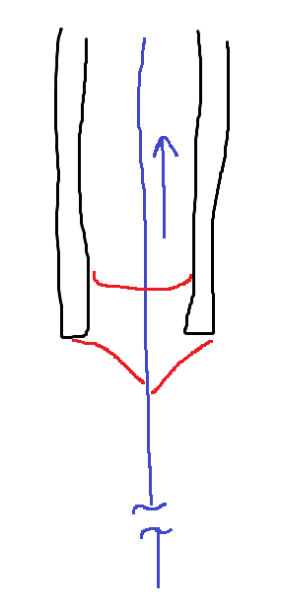 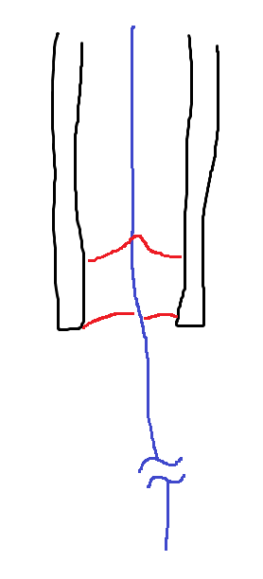 Tetrode in blue, glue in red
   3. Too much slack can tangle the wires
2. Glue the top of the tube
3. Pull the wire straight. With scissors, cut off the tetrode, leaving ½ of the tube’s width in length
   1. 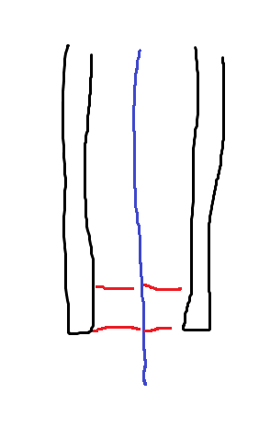
   2. Whenever I use a razor blade, the ends fray

**Option 2: Cut, then Glue (preferrable)**

1. Cut the bottom of the tetrode with scissors close to the tip, leaving ~2 mm at the bottom and ~8 mm at the top
2. Add superglue and pull the tetrode back, leaving ½ of the tube’s width in length
3. 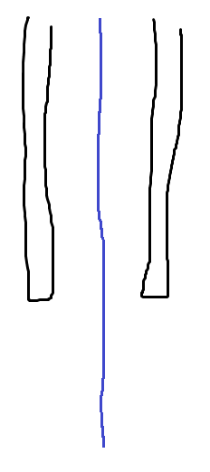 🡺 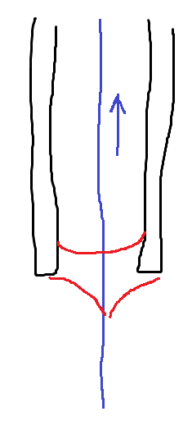🡺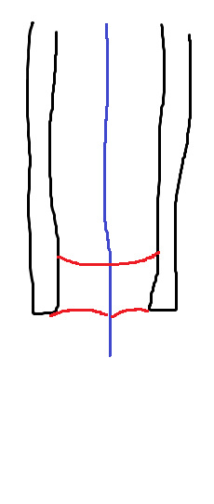
4. Glue the top of the tube

**Finish and Prep for Surgery**

From this point, avoid touching the tip of the tetrode as much as possible.

1. Tighten the screws until the tip of the CA3 tetrodes lines flush with the base of the body
2. Loosen the screws 2.5 turns
   1. This positions the tetrodes to the surface of the brain during implanting
3. Wrap the body in a piece of parafilm, keeping the front screw holes clear for surgery
4. Store the Microdrive in a container, using putty to prevent the tips from hitting the walls and bending